

**Final Report for the E-Project**

JensenDecors

*Jensen is an organization selling wide range of wall decorative products.*

**Group Participants**

|  |  |
| --- | --- |
| **Student Id’s** | **Students Name** |
| Student1502754 | SYED AHMED HASNAIN |
| Student1480985 | MUHAMMAD YASIR NASIR |
| Student1477416 | NAVEESHA ARSHAD |
| Student1481772 | MUHAMMAD HAFEE ALI |
| Student1486092 | SADAF HARIS |
| Student1488046 | ALI AHMED |

Submit To:

Miss Izma

Project Instructor:

Miss Izma

Curriculum Code =

**Acknowledgement**

By the grace of Allah Almighty and through unwavering determination, we are thrilled to present our inaugural e-project, "Jenson Decor." This marks the culmination of our efforts during the FIRST SEMESTER, where we diligently covered essential topics such as HTML, CSS, Javascript and responsive design.

Our assignment centered around creating a website for "Jenson Decor," a task we undertook with enthusiasm and precision. Leveraging the coding capabilities of 'Visual Studio Code,' we meticulously crafted each element to ensure a perfect outlook and functionality.

We believe our project encapsulates all the necessary components, seamlessly integrating them into the final piece. The website reflects our dedication to learning and serves as a testament to our hard work and commitment. We invite and appreciate any suggestions or tips to further enhance the project, as we are open to continuous improvement.

Thank you for considering our efforts, and we hope "Jenson Decor" captures the essence of creativity and learning in the realm of web development.

**Credits**

**Syed Ahmed Hasnain:**

As project lead, Ahmed shaped the design and functionality of jensondecor, providing essential guidance. His oversight of development, coupled with contributions in implementing animations, added a dynamic flair, enhancing the website's visual appeal and user experience.

**Muhammad Yasir Nasir:**

Yasir significantly contributed to jensondecor's aesthetic appeal, showcasing mastery in HTML, CSS, and JavaScript. His attention to detail and commitment to seamless user experience enriched the overall quality of the website.

**Sadaf Haris:**

Sadaf, with a passion for user-centric design, made noteworthy contributions to jensondecor's front-end development. Her keen eye for user experience and interface design ensured a visually appealing and intuitive browsing experience, greatly enhancing the project's success.

**Naveesha Arshad:**

Naveesha's commitment to detail and precision in coding strengthened jensondecor's foundation. Her proficiency in HTML and CSS ensured adherence to best practices, playing a vital role in the project's success.

**Muhammad Hafee Ali:**

Hafee played a crucial role in implementing interactive features on jensondecor. His expertise in JavaScript and front-end development added a dynamic and engaging dimension to the website, significantly contributing to its interactivity.

**Ali Ahmed:**

Ali created a presentation for jensondecor, effectively showcasing the team's efforts and website features. While his direct involvement in development was limited, his dedication to crafting an engaging presentation contributed to communicating the project's goals and achievements.

*A heartfelt appreciation to our teacher for providing valuable guidance and brilliant suggestions, always being a supportive presence.*

*Gratitude to our classmates, each playing a pivotal role; we extend thanks for their encouragement and unwavering moral support throughout our journey.*

We extend our sincere appreciation to **Miss Izma**, our teacher, for her invaluable assistance and unwavering dedication in bringing this concept to fruition.

**Requirement Specification:**

The Web site is to be created based on the following requirements.

1)The Home Page should be created making use of Sections with a suitable logo,

the header section can be added which will show images of various decorative

products

2)The site must contain the links to navigate through any category for the

information.

3)The site should display a menu which will contain following categories of

products

* Metal wall art
* Wall papers
* Photo frame art
* Mirror art
* Wall shelves
* Wall mounted animals

4)Each menu option mentioned above should have sub categories according to

the range of products available in that category.

5)The information should be categorized according to the brand names of the

products like if a User wants to see only “Gloster” products or any other

company products then he/she can click on a Link/button/menu etc and can

see only that Brand chairs.

6)When a user selects any particular brand, a list of products for that brand will

be displayed

7)A brief summary of features of the products should be displayed on the Web

Page along with the picture but detailed Features should be stored in

Individual Word documents which can be downloaded or viewed by the User

who wishes to see the same.

8)The user should also be able to compare the various products of different as

well as similar brands.

9)There should be a “Contact Us” page which will have the Address of the

Company which should be displayed using GeoLocation API (eg. GoogleMaps)

and the email address which when clicked will invoke the local mail client from

where they can send an email.

**Problem Statement**

Jensen is an organization selling wide range of wall decorative products.

They deal in various types of items suiting every requirement office to homeand etc.

You are supposed to create a website for them with the below mentioned

requirement specifications.

The website is to be developed for the Windows Platform using HTML5,  JavaScript and Geolocation.

The site should work well in all leading browsers including Chrome, IE,

Firefox etc.

**Hardware/ Software Requirements**

**Hardware**

∙A minimum computer system that will help you access all the tools in the

courses is a Pentium 166 or better

∙64 Megabytes of RAM or better

**Software *[Either or Combination as per Course/Sem]***

•Notepad/HTML editor/CoffeeCup

•Angular / Angular JS / React / BootStrap

•Dreamweaver / Figma

•MS IE / Chrome / FireFox / Netscape /MS Edge

Header

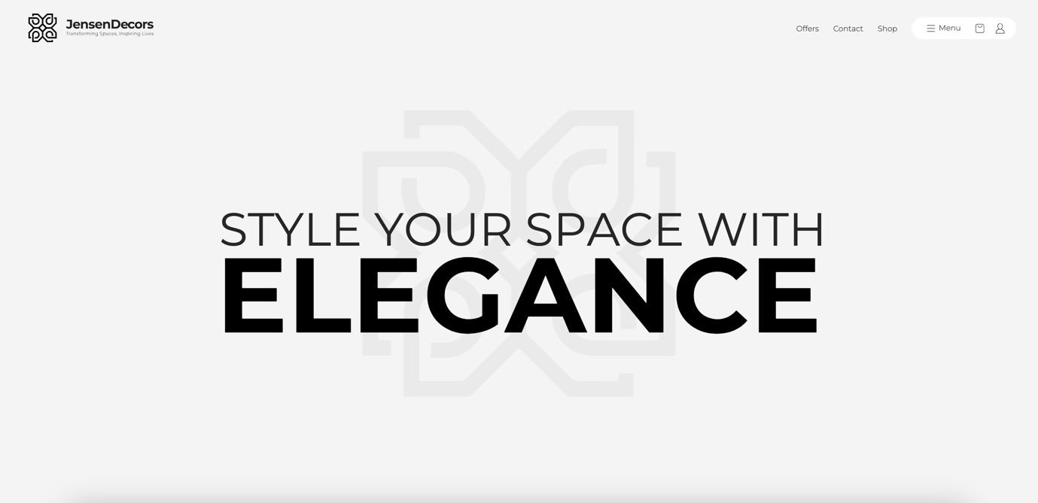HomePage

HomePage – About Section HomePage – Category Section

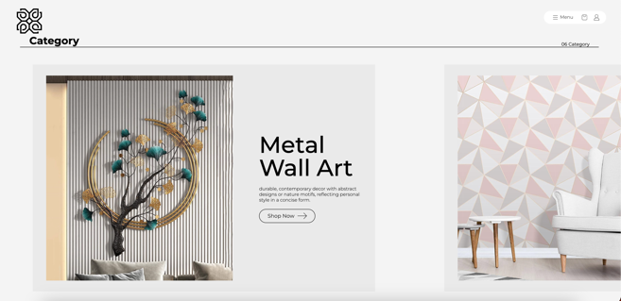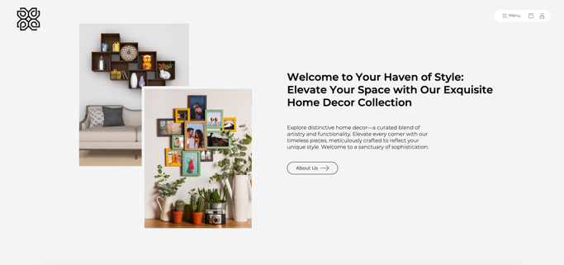

HomePage – Products Section Testimonial

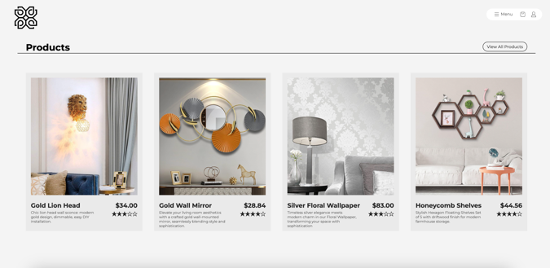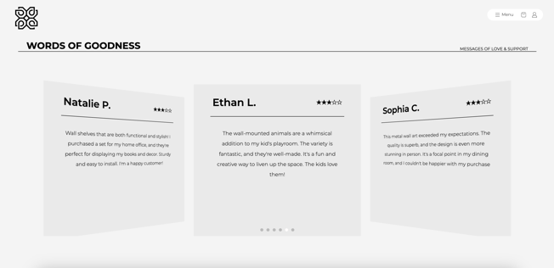

**Shop-Page**

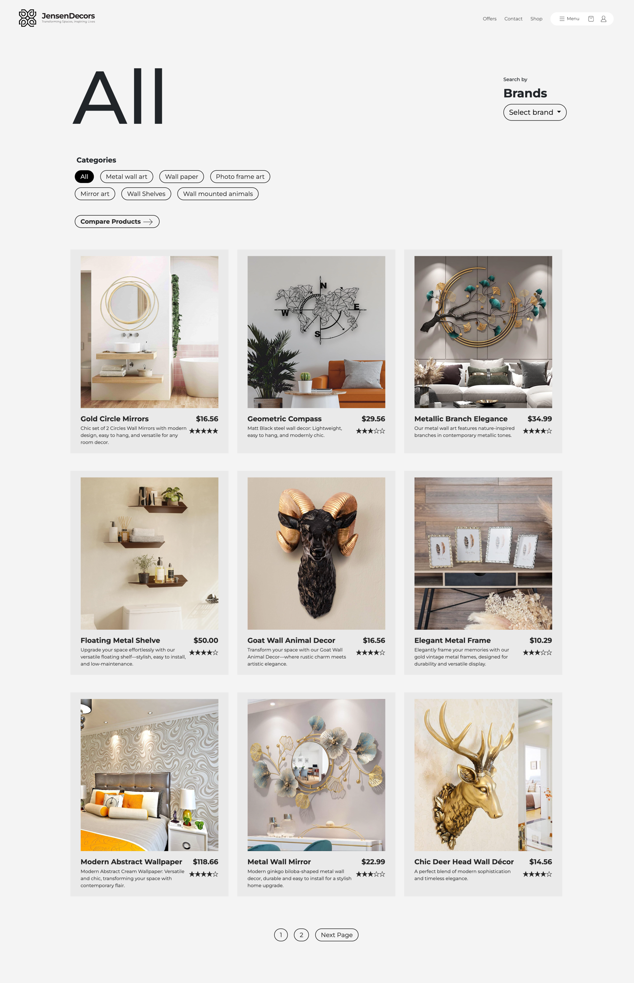

**Product – detailed page**

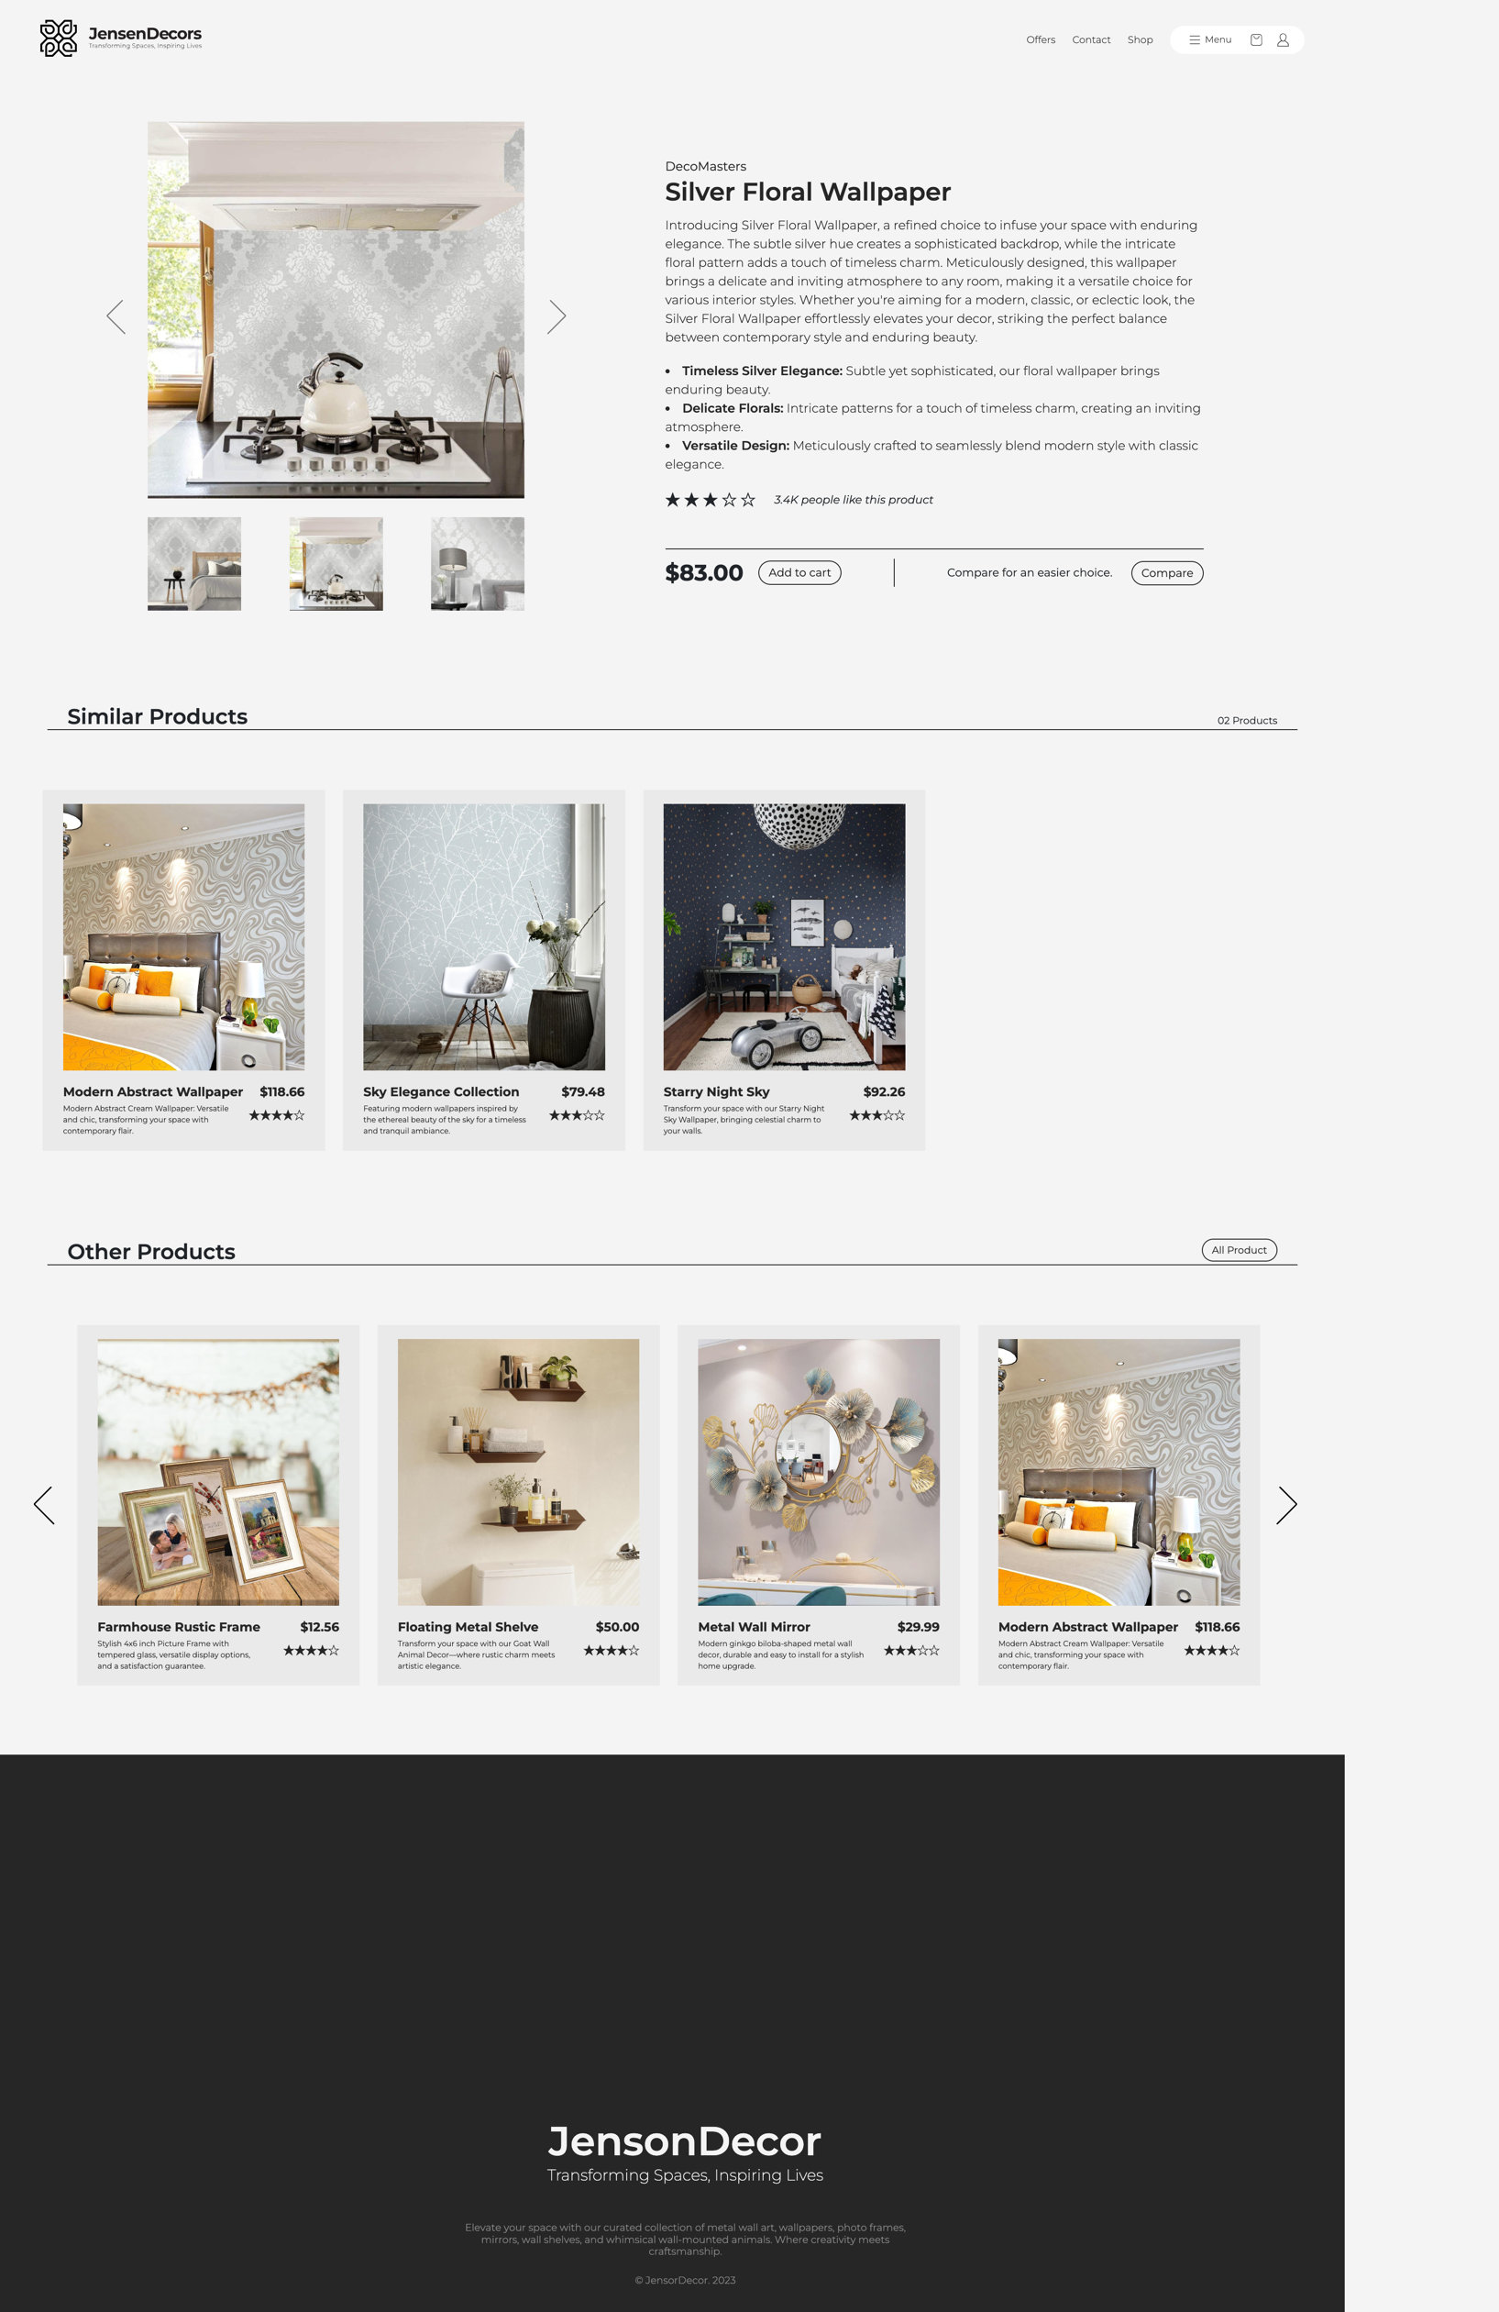

**Contact Page**

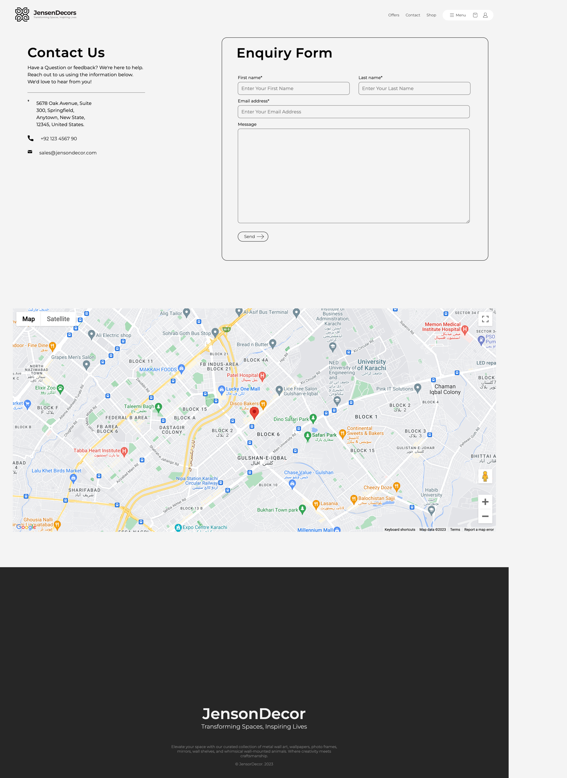

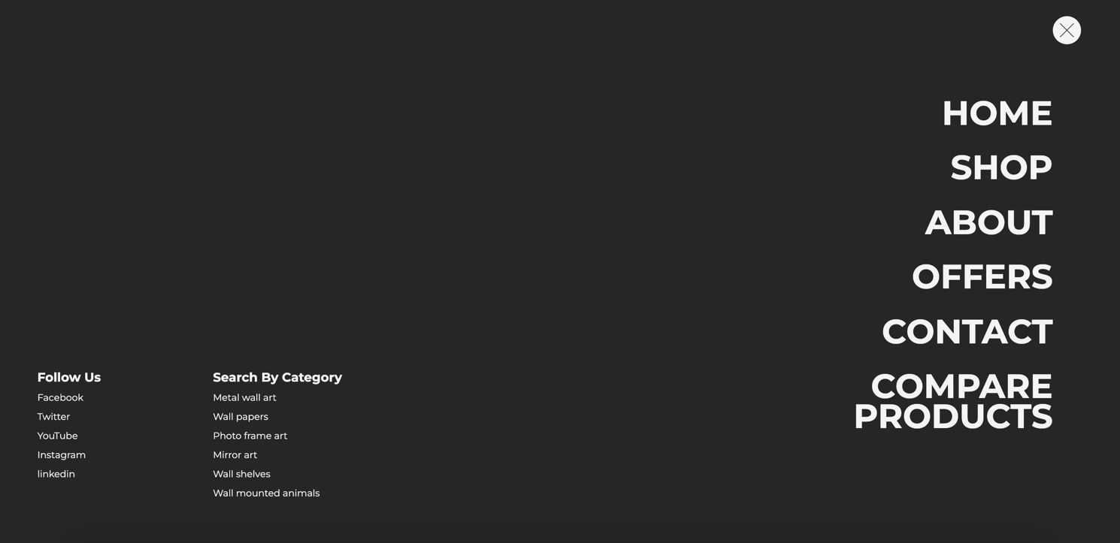**Menu**

Footer

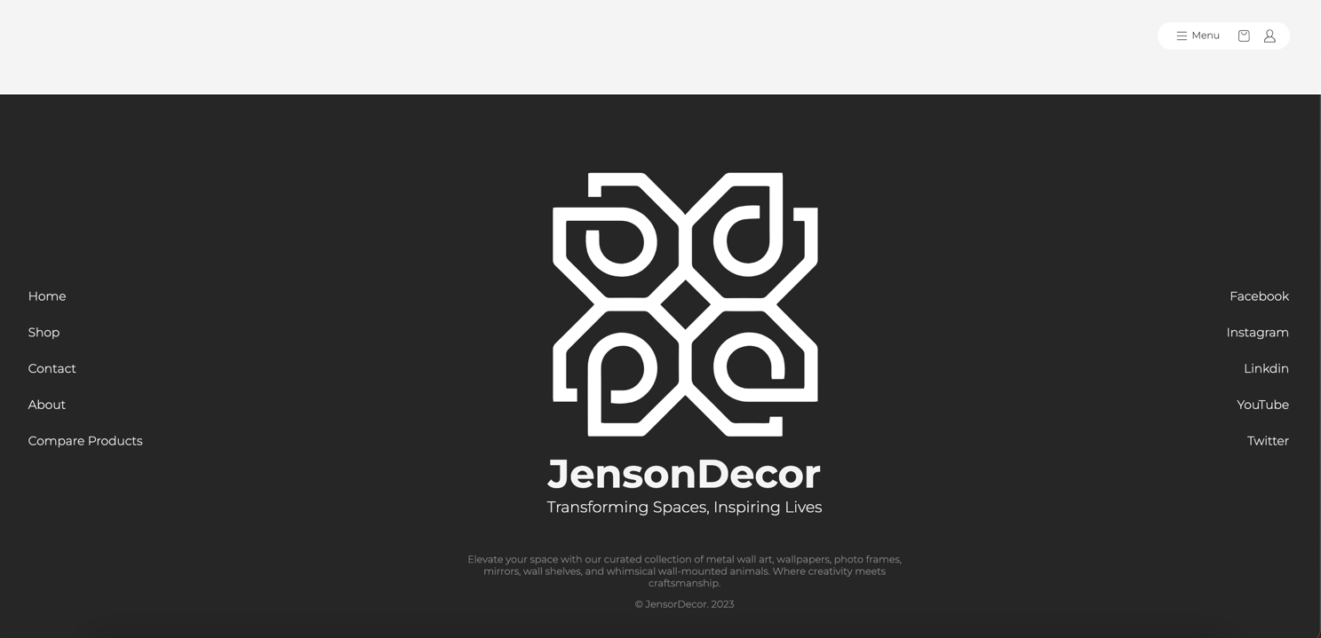

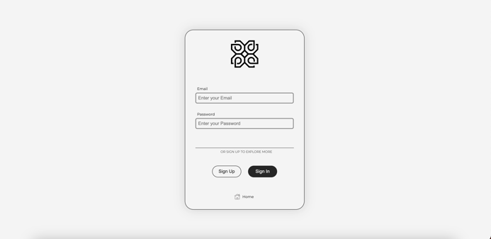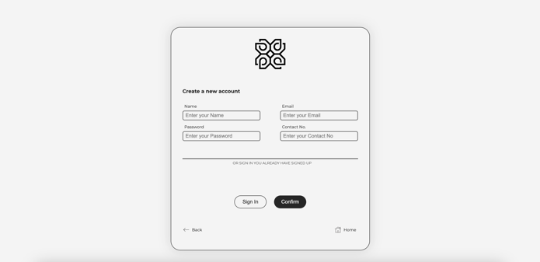Sign-up Page Sign-in Page

Thank You